## horizontal line



**Testing for Flappy Bird**

17.02.2019

**─**

|  |  |
| --- | --- |
| Md Shihab Uddin  ID: 1510792042  CSE427.1  North South University | Akiba Amrin  ID: 1510310042  CSE427.1  North South University |

# Specification

*Flappy Bird* is aside-scrollingJava PC game featuring2Dretro style graphics. The objective was to direct a flying bird, named "Faby", who moves continuously to the right, between sets ofMario-like pipes. If the player touches the pipes, theylose. Faby briefly flaps upward each time that the player taps the screen; if the screen is not tapped, Faby falls because ofgravity, each pair of pipes that he navigates between earns the player a singlepoint. And Game is over if the bird touches the ground or any wall.

Figure: Flappy Bird Game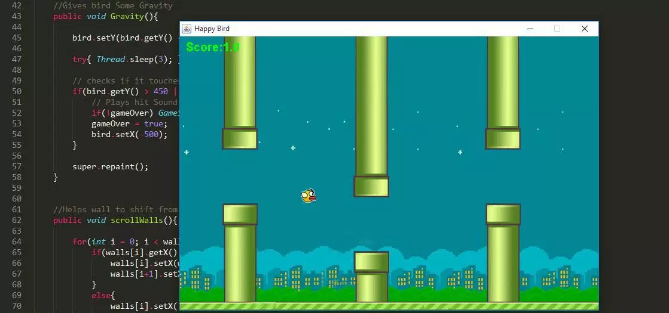

# Goals

This game was developed in JAVA as our CSE215 project. In CSE427, our main goal is to develop the test suite using JAVA JUnit.

1. Testing Each Methods (Unit Test).
2. Module Testing.
3. System Testing

Conclusion

The purpose of this project is to fully implement all testing learnt in CSE427: Software Testing & Quality Assurance course.